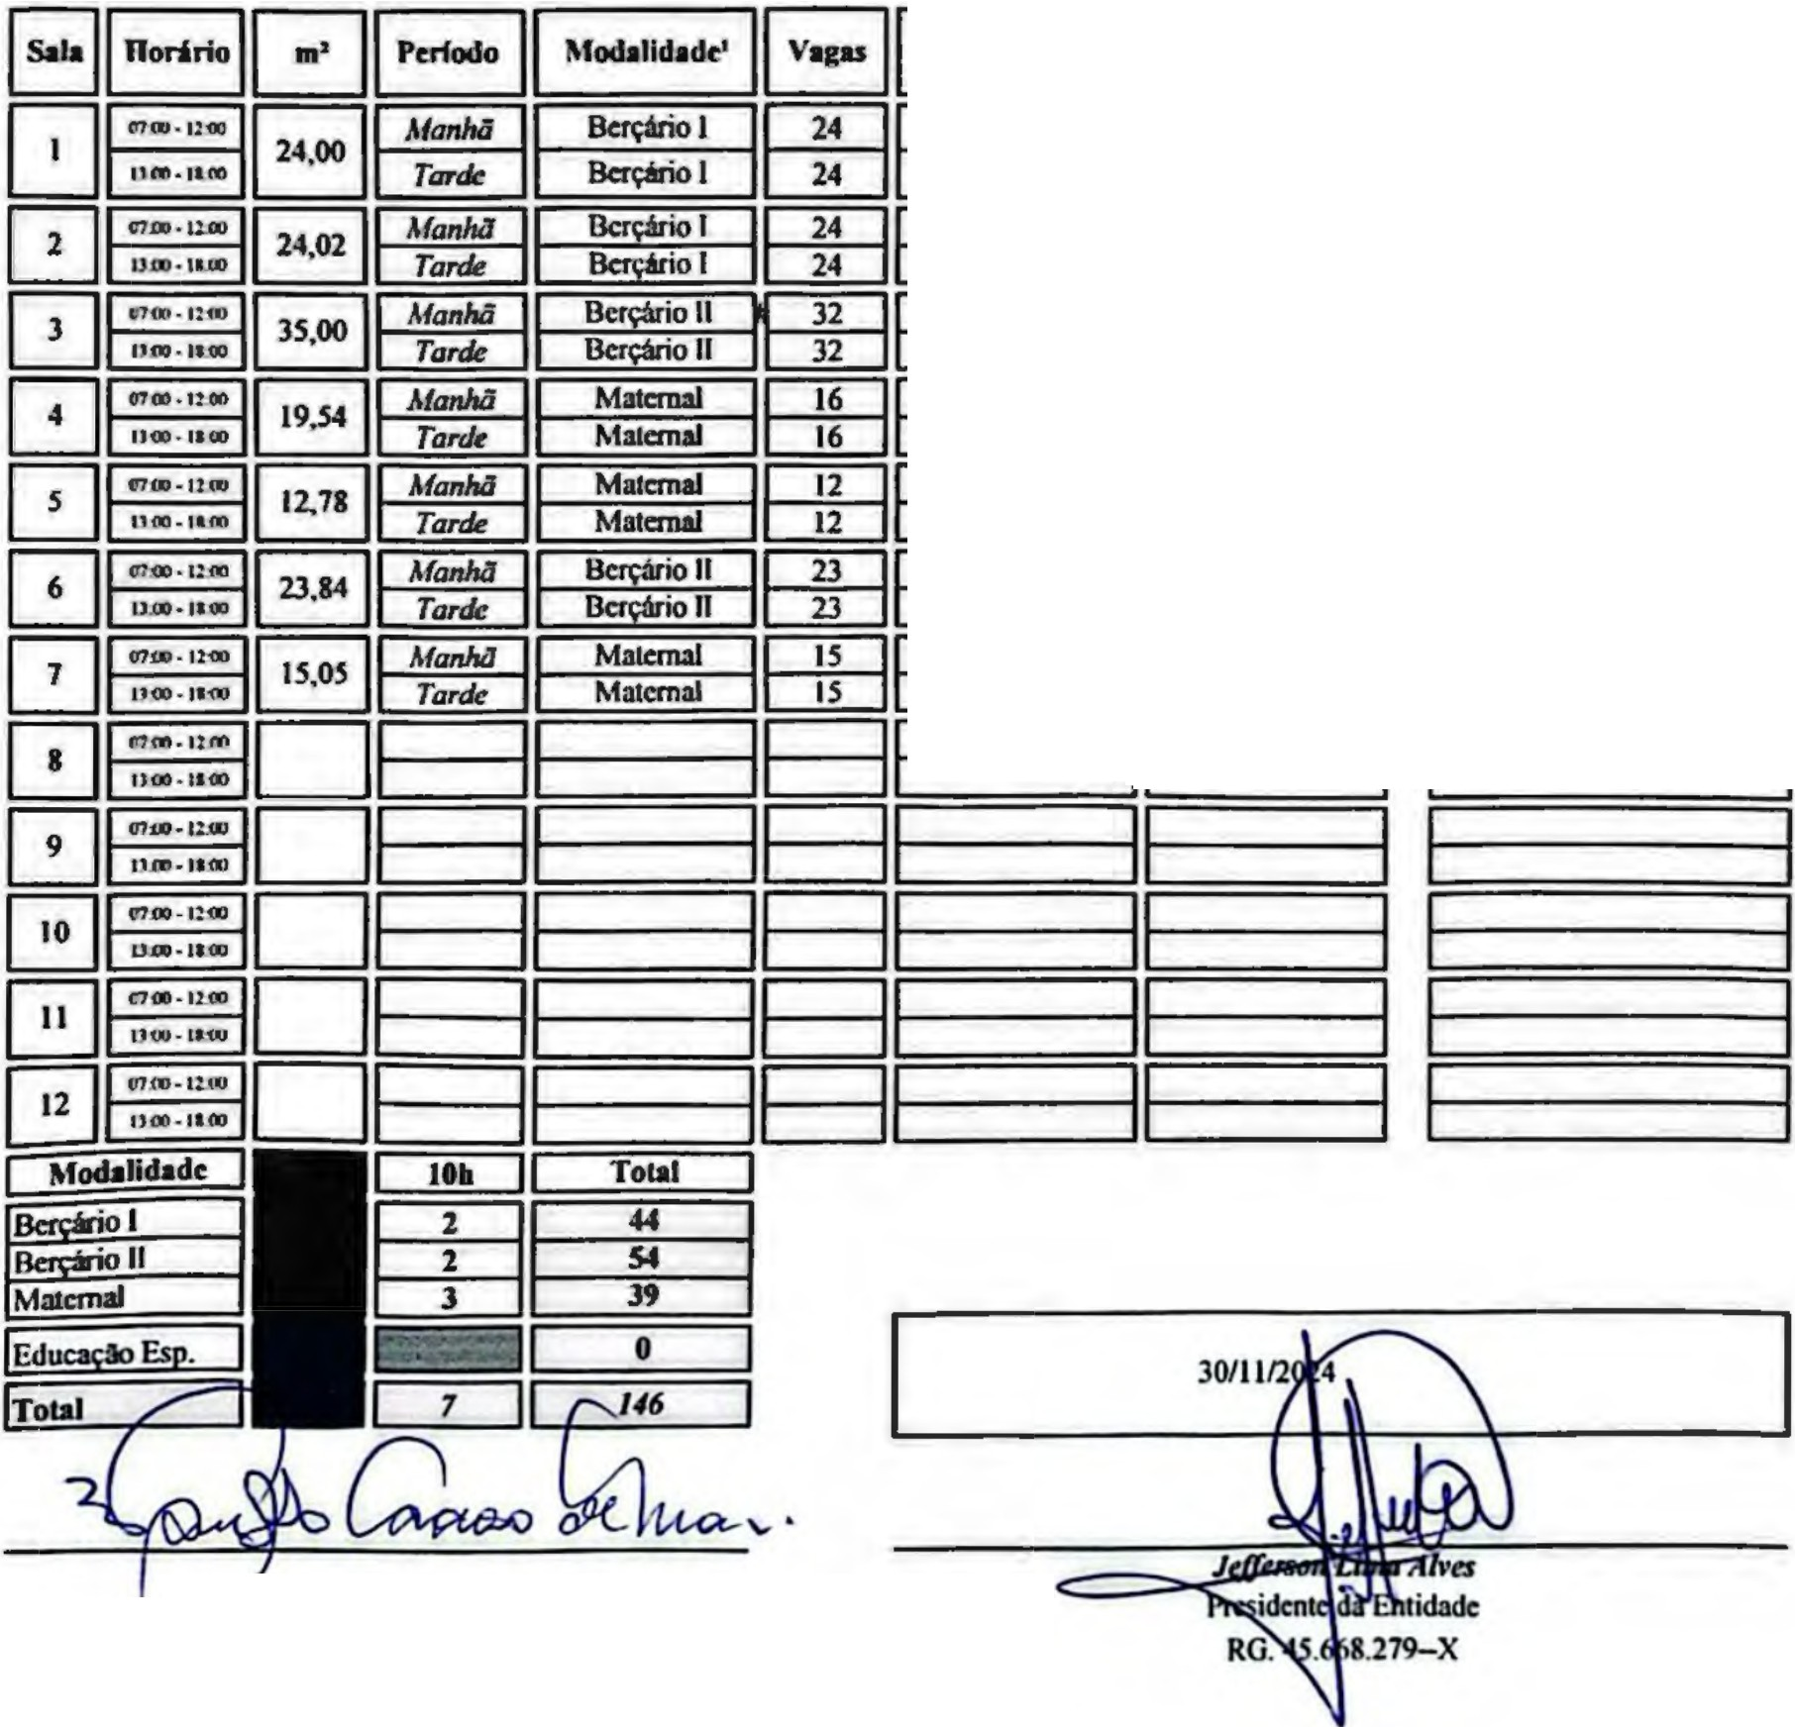
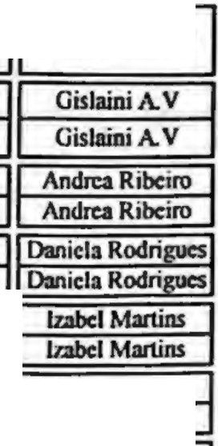
ASSOCIAÇÃO LUIZ CARLOS LEITE
Off'J: U.'9Z..US/OOOJ-M - T-. (111 JSll.4nl. •- 5MlMiL 551-01072--W. AOMl!a- - SP.

ANEXO Ili- EDUCAÇÃO INFANTIL - CRECHE
Quadro dt Classa t DocOllt!S - 20U ! N9 de wrps"""1 ! U6
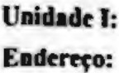
ALCL uiiz Carlos l..c:ilc AS1Cx:i!'k!>
Av Slo Lui7_ rf' 567
..

Rnpo■Nvrf
rRcspownl
r Respo11sAnl
MichcUc Silva Michclle Silva
Jancide Anuda
Janc:ide Anuda
Tatianc: l.im:i
Tlli■nc Lima

FcranadaMcocs= Fcnmda Mcncsscs
Pllricia Purilica,;ao Patricia Purilica,;io
PalomaSilva Paloma Silva
Cristianc Almcidc 1
Crislianc Almcide:
Patricia Moura
P■uicia Moura li
Isabel Sam;io

Tatianc Bmos

Barbar.! S. Maia
Isabel Sam •o li Ta1ianc Barros
Juliana Batista
Osbani S. Maia
Juliana Balista 1
1

Vanessa Cardoso de M<U11
RG. 28.971.115-0

Scanned with
CamScanner-

